

**ELECTENG 734 - Power Electronics**

Laboratory Assignment – Pick-up Regulator

Developed by Jackman Lin, M. Pearce & D. Thrimawithana

# Introduction

In this laboratory you will be performing theoretical calculations as well as simulations using PLECS of an IPT pick-up circuit similar to what you will design and construct later in this course.

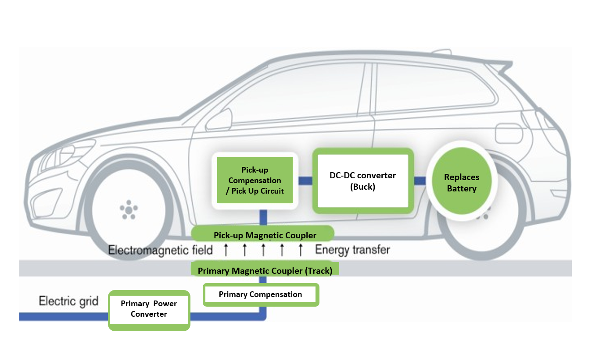

# Simulation with PLECs

These simulations are run using PLECS Blockset package for Matlab Simulink. To open the simulation software and load a file:

* Open MATLAB
* Open Simulink file Lab_IPT_Student.slx (*this will take a little while to load*)
* Double click on the IPTQ1 PLECS circuit to view it (*right click menu will allow you to comment out PLECS circuits)*
* Ctrl-T to run simulation

Note that in PLECS, plots are produced by using a probe block connected to a scope block. Components may be added to the probe block by dragging and dropping them to the open probe block. You may redefine the number of scope channels in the scope if you want to.

You may add components by going (from the Simulink window) View -> Library Browser, then selecting PLECS and double clicking the Components block.

For further information on how to use PLECS refer to the PLECS user manual ([www.plexim.com/files/plecsmanual.pdf](http://www.plexim.com/files/plecsmanual.pdf)).

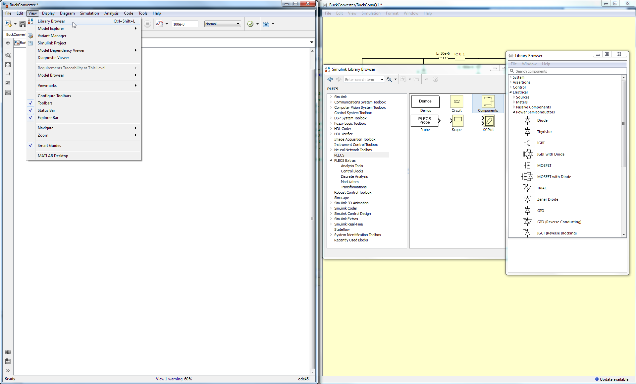

# Pick-up Specifications

In this lab we will look at the operating principles of the IPT pick-up used in your toy car by simulating an IPT pick-up with following parameters in PLECS.

|  |  |  |  |
| --- | --- | --- | --- |
| **Parameter** | **Symbol** | **Value** | **Unit** |
| Track Current | $$I_{1}$$ | 80 | A |
| Track Frequency | $$f_{1}$$ | 38.4 | kHz |
| Primary (Track) Inductance | $$L_{1}$$ | 10 | $μ$ H |
| Secondary (Pick-up) Inductance | $$L_{2}$$ | 40 | $μ$ H |
| Coupling factor | $$k$$ | 5 | % |
| Load Voltage | $$V_{L}$$ | 16 ± 0.5 | V |

# Submission Instructions

For this online lab, submit a pdf document with the answers to each task.

For all working, either by typing into word, or through evidence by showing photos of the work.

## Presenting information

Follow these instructions to make sure that any screenshots are legible:

* For any ac waveforms, only include up to two periods of the simulation
* For any dc waveforms, ensure that the measurement is being taken at steady state
* When calculating rms values, make sure the cursors are covering at least one period
* Use the built-in measurement tools provided in PLECs

# Task I - Voc and Isc

*A partially completed simulation model is provided to you in Lab_IPT_Student.slx. Ensure IPTQ1 is the only circuit uncommented and double click to open it.*

Setup the coupling between the coils in the mutual inductor model

$\left[\begin{matrix}L_{1} & M \\ M & L_{2}\end{matrix}\right]$

Where:

* *L1* is the self-inductance of the primary.
* *L2*is the self-inductance of the pick-up winding
* M (mutual inductance) is $k\sqrt{L_{1}L_{2}}$ where *k* is the coupling factor between L1 and L2

Enter the values into the Block parameters for the magnetic couplers (by double clicking on pads) and run the simulation. Copy paste the simulation results for open circuit voltage, and short circuit current into a document.

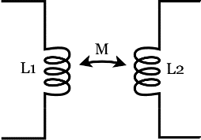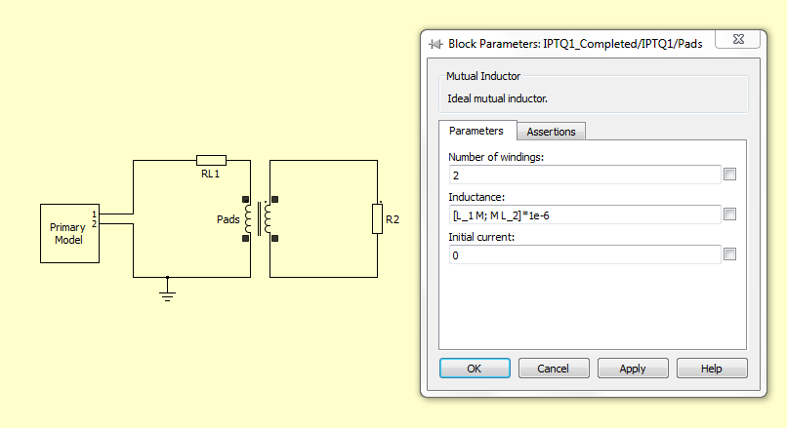

## Questions

1. Assuming ideal conditions, calculate $V_{OC}$ and $I_{SC}$ of the pick-up. Verify that the theory matches the simulated values

*Hint: Use 0Ω or remove the resistor to simulate short circuit and open circuit conditions.*

1. Determine maximum uncompensated power of the pick-up and verify using the simulation.

*Hint: Use maximum power transfer theory.*

# Task II - Compensating the Pick-up Coupler

*A partially completed simulation model is provided to you, comment out IPTQ1 and ensure IPTQ2 is the only circuit uncommented and double click to open it. You will have to fill in the Mutual Inductor model parameters you calculated earlier before continuing.*

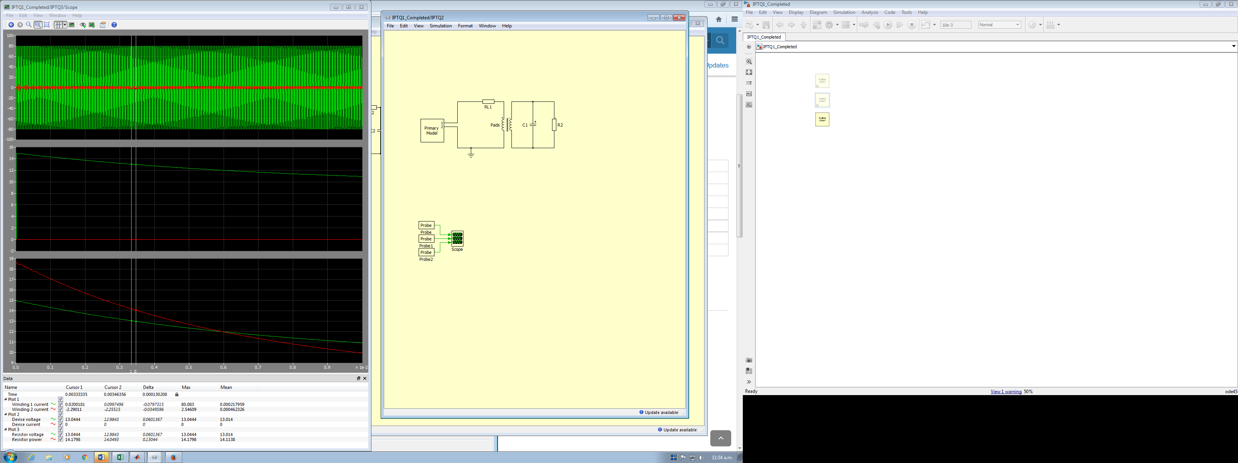

Determine the compensation capacitance required to parallel tune the pick-up inductor and insert the value into C1. Run the simulations for R2 values of 2, 4, 8, 12 and 16 Ω. Take screenshots of each output voltage and output voltage waveforms.

## Questions

1. Plot theoretical (assuming no losses) output voltage and output power for load resistance values of 2, 4, 8, 12 and 16 Ω (R2 on x-axis and Po/Vo on y-axis). Verify your theoretical answers using the simulation model.
2. Compare the output power of the compensated system with maximum output power of the uncompensated pick-up. Which system can deliver more power? By how much? Why?

# Task III - Short Circuit Controller

As discussed in the lectures, the parallel compensated pick-up acts as an AC current source. This is rectified, filtered, and regulated to produce a constant DC voltage to supply the Buck converter, which can be modelled as a load resistor. A slow-switching short circuit controller with a hysteretic controller is used to regulate the output voltage of the pick-up circuit. Your task is to design a slow-switching Short Circuit Controller to limit the voltage across the load (VL­) to 16V ± 0.5V. Use a Schmitt trigger with a MOSFET as given below.

*A partially completed simulation model is provided to you, comment out IPTQ2 and ensure IPTQ3 is the only circuit uncommented and double click to open it. You will have to fill in the Mutual Inductor model parameters and C2 value you calculated earlier before continuing.*

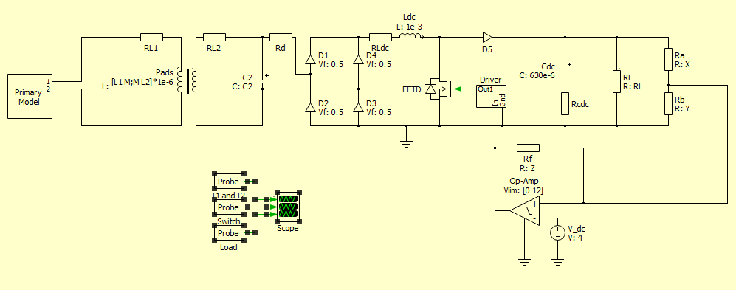

The values that need to be calculated are Ra, Rb and Rf. You may use an online calculator to calculate the values but you are expected to know how to derive it by hand. The analysis can be simplified by combining Ra and Rb to its Thevenin equivalent and using the standard Schmitt Trigger equations given in <https://en.wikipedia.org/wiki/Schmitt_trigger#Non-inverting_Schmitt_trigger>. Use standard resistor values from the E12 series ([http://jansson.us/ resistors.html](http://jansson.us/%20resistors.html)).

Complete the following tasks:

## Questions

1. Plot theoretical (assuming no losses) output voltage and output power for load resistance values of 2, 4, 8, 12 and 16 Ω (RL on x-axis and Po/Vo on y-axis).
2. Calculate the expected switching frequencies and duty cycles of the simulation for each load.
3. Verify your theoretical answers using the simulation model. In the simulation, note down the switching duty cycle and frequency. You are expected to do individual simulations for each load resistance value and plot the results alongside the theoretical results.

*Hint: Set Ra = 10 kΩ*

1. At what load do you observe maximum output power and why?
2. What is the maximum switching frequency of the simulated system?

# (Optional) Task IV - Impact of coupling change

In a practical IPT system, the mutual inductance between the track and the pick-up will change depending on the relative position between the two magnetic structures. Your task is to investigate how a change in mutual inductance impacts the various voltages and currents in a parallel tuned IPT system with a hysteric controller

Increase the coupling factor from the 5% used in the previous tasks to 30%. Modify the inductance matrix in IPTQ3 and run the simulation.

## Questions

1. What is the short circuit current and uncompensated volt-amps of the parallel tuned system at this coupling factor?
2. Briefly discuss the differences between this simulation and the simulation results from Task 3a. Observe the following parameters:
   1. Secondary coil current
   2. Switching frequency
   3. Duty cycle
   4. Output voltage
   5. Output power

You are not required to do any calculations.

1. What practical considerations do you need to think about when designing a system with large coupling swings?

*Hint: Think about your copper diameter, and losses in the switch*

# Optional Tasks

1. Look at the sensitivity of the output power to variations in the value of compensation capacitor. (*Do a parameter sweep from MATLAB and plot power for different capacitor values.*)
2. Investigate losses of the pick-up circuit. (*Thermal simulation is done separately and thus is not included in standard simulation. Resistance losses can be measured from Pin – Pout, but switch losses and diode losses need to be accounted for in thermal simulation.*)